Writeup for Homework 9 SQL Sajid Anjum 12.01.22

I have included the create_tables schema and the homework queries in separate .sql files. Here, I will just show the results of the queries and some observations.

Query 1

List the following details of each employee: employee number, last name, first name, sex, and salary.

I observe many employees with their last names, first names, sex, and salaries.

Query 2

List first name, last name, and hire date for employees who were hired in 1986.

I observe that all these employees were hired in the year 1986

Query 3

List the manager of each department with the following information: department number, department name, the manager's employee number, last name, first name.

I see that most departments have two or three managers.

Query 4

List the department of each employee with the following information: employee number, last name, first name, and department name.

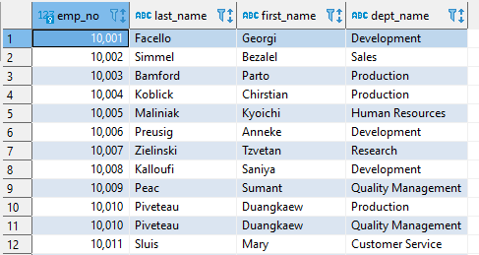

This is a list of all the employees and the departments they work for

Query 5

List first name, last name, and sex for employees whose first name is "Hercules" and last names begin with "B."

This company has twenty people named Hercules with a last name beginning with B.

Query 6:

List all employees in the Sales department, including their employee number, last name, first name, and department name.

These are a bunch of people who work in sales

Query 7

List all employees in the Sales and Development departments, including their employee number, last name, first name, and department name.

These are a bunch of people who work in either sales or development

Query 8

List the frequency count of employee last names (i.e., how many employees share each last name) in descending order.

I see that Baba is the most common name at this company.

BONUS:

This is a histogram of employee salaries at this corporation. Out of 300,024 salaries, 126,271 salaries are between 40,000 and 45,000 dollars. This is 42.09% of the total salaries

This is the averages of employee salaries by department. I see that only three departments have average salaries greater than 50,000. They are finance, sales, and marketing.